The effect of Mechanical Keyboard and Membrane Keyboard on typing speed

# Abstract

The purpose of this study was to evaluate the effect of different types of keyboards on the users’ typing speed, which was measured in Words Per Minute (WPM). The test was conducted using two different keyboards: Mechanical Keyboards (NK65 with NK Blueberry switches) and Membrane Keyboard (XPS 13 2020 keyboard). 50 observations were collected for each keyboard and are later compared to see if there is a significant difference between the typing speed. We found that there was no significant difference in mean WPM for mechanical keyboard and membrane keyboard (p-value = 0.191)

# 

# Background and Significance

An association between the use of computer keyboards and upper extremity musculoskeletal disorders (MSDs) has been shown by many previous studies (Andersen et al., 2011). The reasons usually include highly repetitive movements, typing force, muscle activity, and awkward (wrist) postures during computer keyboard typing, all of which are directly affected by the physical characteristics of keyboards. The accumulation of these micro traumas over the long term is an underlying mechanism for computer-related MSDs. Moreover, these traumatic and uncomfortable movements caused by inappropriate keyboard designs can significantly reduce working efficiency. Hence, ergonomic science has been involved to change keyboard configurations and positions in order to reduce operators’ fatigue and discomfort.

However, laptop keyboards have been gravitating towards thinner designs to increase portability and have a more visually appealing design, and the key travel distances have substantially decreased from 4.0 mm (conventional detachable desktop keyboards) to less than 2.0 mm (ultra-low travel keyboards) (Sisley et al., 2017). While most of the studies focus on how this change affects biomechanical risk factors (Andersen et al., 2011), there is little done on how these changes made a difference to the operators’ working efficiency.

Therefore, we decided to conduct our own observations and compare the typing speed when using two keyboards with significant differences in key travel distance. Our hypothesis is that the typing speed for membrane keyboards is higher than mechanical keyboards’ due to its short travel distance and low actuation force.

# Method

1. ***Data collection***

There were 101 observations which were collected by typing and recording the WPM on the website typing.works. The typist is a male, right-handed, with a hand size of 7.0868 inch (lower than American average), touch typist and the owner of the keyboard being tested on, therefore it is safe to assume a relatively high level of acquaintance with these keyboards. We type on the website using two different keyboards. One is a mechanical keyboard, using NK Blueberry switches, a tactile mechanical switch with a 3mm key travel distance and 70g actuation force. The other is a membrane keyboard from a XPS 13 2 in 1 (7390) Laptop. The specification for this keyboard is unknown, therefore we assume it has a 2mm travel distance, which is the common figuration for most laptop keyboards. The typing speed was measured after typing one random English sentence in WPM, and this test was carried out 101 times.

1. ***Variable Creation***

We’re looking at two variables in this project: WPM (quantitative) and types of keyboards (categorical). WPM is an acronym for words per minute, representing the typers’ speed.

1. ***Analytic Methods***

Since we have a case CQ in our data, we are going to use box plot and individual histograms to illustrate differences in WPM between the two types of keyboards.

# Results

***Descriptive statistics:***

The observations were 50.5% membrane and 49.5% mechanical. The mean WPM for both types of keyboard was 67.02 WPM with a standard deviation of 5.411063.

In the side by side boxplot, the range for membrane keyboard is shown to be 54 to 77, the mean WPM for membrane was 67.4902 and the variance was 26.41490. For mechanical keyboards, we observed that the range for mechanical keyboards was 51-79, the mean WPM for mechanical was 66.54 and the variance was 32.34.

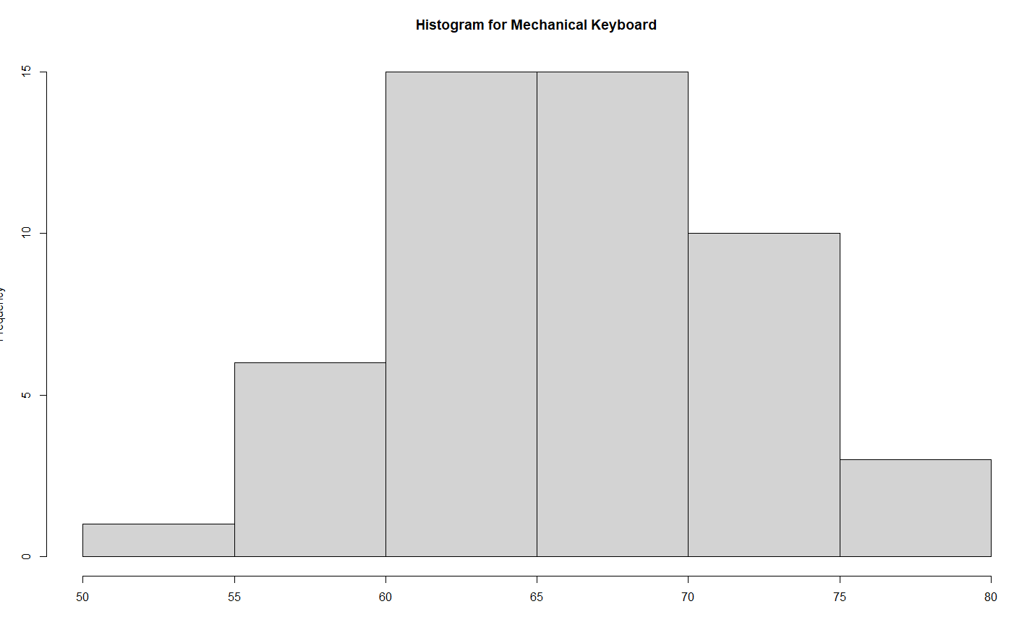Fig1: Histogram of Mechanical Keyboard’s WPM

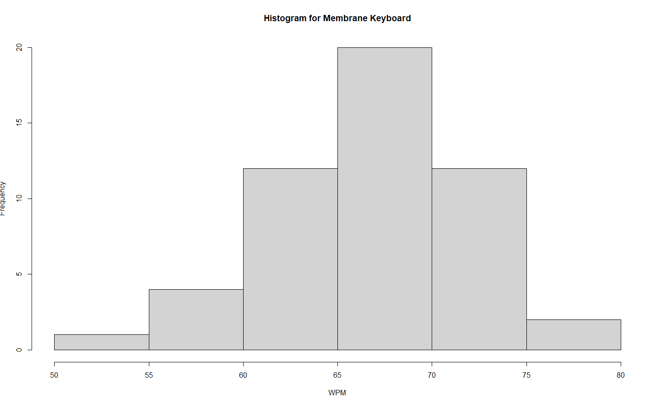

Fig2: Histogram of Membrane Keyboard’s WPM

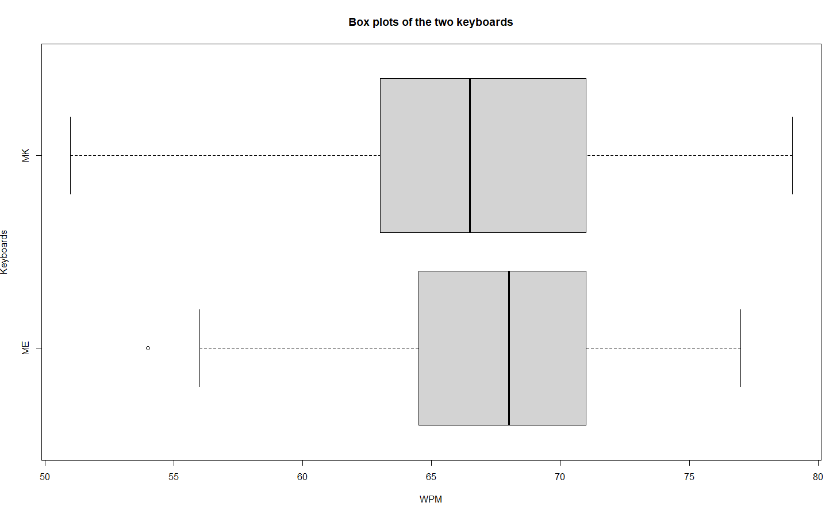

Fig3: Side by side boxplot of WPM based on types of keyboards

Since the samples are independent with unequal population variance and the population for both samples are greater than 30, we believe that the data can be used in hypothesis tests.

***Inferential statistics:***

We followed up the descriptive statistics with a t-test. In this t-test, the null hypothesis was that there was no difference in the typing speed for membrane and mechanical keyboard. The alternative hypothesis is that on average, the typing speed for membrane keyboards is higher than for mechanical keyboards with a significance level of 0.05. We obtained a p-value of 0.191> 0.05 (t = 0.8804) which suggests that the null should not be rejected, and there is insufficient evidence to conclude that on average, the typing speed of membrane keyboards is higher than that of mechanical keyboards.

# 

# Discussion/Conclusions

***Limitation***

Overall, there are many factors affecting the typing speed. Accuracy is also a contributor to typing speed - there is a trade-off between accuracy and typing speed (mistyping will lead to retyping and ultimately causes more time). Hence, factors affecting accuracy should also be considered. However, for simplicity, we do not include such measures in our paper. Additionally, limited sets of sentences provided in the website typing.works give the typer some familiarity with the repeated test sentences, which potentially leads to a higher WPM. Fatigue from typing for repeated succession can also result in lower WPM.

# *Conclusion*

We attempted to answer the question of whether typing on membrane keyboards is faster than mechanical keyboards. We found that there was no significant difference in mean WPM for mechanical keyboard and membrane keyboard (p-value = 0.191) This is what the main question was focused on, and it was also opposite of our hypothesis. We originally thought that membrane keyboards would be faster to type on due to their low actuation force and short travel distance (approximately 2mm) (Sisley et al., 2017). From the data collected, it appears that our hypothesis was incorrect, and that the type of keyboard has little effect on the speed of a typist.

# References

Kia, Kiana et al. “Differences in typing forces, muscle activity, wrist posture, typing performance, and self-reported comfort among conventional and ultra-low travel keyboards.” Applied ergonomics vol. 74 (2019): 10-16. doi:10.1016/j.apergo.2018.07.014

Sisley, Jonathan, et al. “Effects of Key Travel Distances on Biomechanical Exposures and Typing Performance During UltraLow Key Travel Keyboards.” Proceedings of the Human Factors and Ergonomics Society Annual Meeting, vol. 61, no. 1, Sept. 2017, pp. 981–985, doi:10.1177/1541931213601727.

# Appendix

Fig1: Histogram of Mechanical Keyboard’s WPM



Fig2: Histogram of Membrane Keyboard WPM

Histogram of Membrane Keyboard’s WPM:

According to this histogram, we see that the typist’s speed is mostly around 65 - 70 WPM on a membrane keyboard

Histogram of Mechanical Keyboard’s WPM:

According to this histogram, we see that the typist’s speed is mostly around the range of 60-70 WPM on a mechanical keyboard.



Fig3: Side by side boxplot of WPM based on types of keyboards

According to this multiple box plot (Fig 3), the Mechanical Keyboard has a larger spread. However the mean score for Mechanical Keyboard is lower. This shows that the big spread in the mechanical keyboard doesn’t make a difference to the mean scores.